FORMAL ARCHIVES C.22
DULOE
The Formal Archive material about the patronage of Duloe in Cornwall is all in one box coded C.22. The College acquired the Advowson in 1701, but the majority of the documents in C.22 predate that. The brief list made in the 19th century has many muddles with cryptic descriptions which do not correspond to actuality all; and many of the documents have 19th century pencil annotations which compound the confusions, not least by numbering some items with two numbers .The condition of most of the pre-1700 documents in C.22 is poor .The completely revised list which follows uses for reference the numbers on the small red edged paper labels which were applied previously.
There is also copious correspondence etc concerning Duloe ca 1860-recent times which awaits detailed cataloguing; some of recent date is closed.
Caveat: the documents do not always instantly make it obvious whether an individual incumbent was Rector or Vicar, and the C of E database as at this date is lacking regarding Duloe.

C.22.1. Conveyance of the Advowson, 23 July 1701, Sir John Saint Aubyn Bt of Clowance Cornwall and John Arundell Esq. of Tremidart Cornwall to the College, for considerations of £350 to each vendor, reciting then recent history of the Advowson in the St Aubyn and Arundell (Arundel) families. Stiff parchment, badly folded.
C.22.2. ALS, 14 July 1701, Richard Kidder Bishop of Bath & Wells from Wells to Roger Mander Vice chancellor of Oxford at Balliol, concerning “ye method of conveighing ye advowson to yr College”. Annotated “Free” and signed “R Bath & Wells” after closure. Sir J Powell is mentioned as one who would be consulted. It is possible however that this letter concerns some other Advowson in the west of England, as Duloe (which was in the Diocese of Exeter, not Bath & Wells) is not named.
C.22.3. Release, 10 October 1704, citing C.22.1, by John Arundell Junior son and heir apparent of John Arundell, to the College, of his rights to the Advowson, for a consideration of 5s.
C.22.4. Presentation, 3 April 1705, of Jonathan Edwards STP to the Church of Duloe. The seal and its tag have been removed.
C.22.5. Presentation, 4 July 1711, of George Cooper to the Church of Duloe. With a poor and broken impression of the great St Catherine seal of the College attached.
C.22.6. Conveyance, 16 March 1839, the Guardians of the Poor of the Liskeard Union, Absalom Heathman & Edward Ladner (Churchwardens) and John Broad, Samuel May & Joseph Stick (Overseers of the Poor of the Parish of Duloe in the said Union), to the Revd Charles Atmore Ogilvie, of a house in the Village of Duloe lately occupied by the paupers of the said Parish, with the waste ground thereto belonging. Signed by the Churchwardens and Overseers (except by John Broad who made his mark) in the presence of Jos: Chapman; signed by CA Ogilvie in the presence of John Best; sealed by the Guardians of the Union at a Board Meeting on 16 March 1839, chaired by John Allen (Peter Glubb was then Clerk of the Union ); approved and registered by the Poor Law Commissioners on 17 May 1839.The seal of the Liskeard Union is oval approx. 2.5 x 3.0cm, a perfect impression. Inside the document as folded is a loose oval note bearing the same code C,22.6, in the hand of Richard Jenkyns Master of Balliol concerning the purchase, in which CA Ogilvie was no doubt acting for the College.
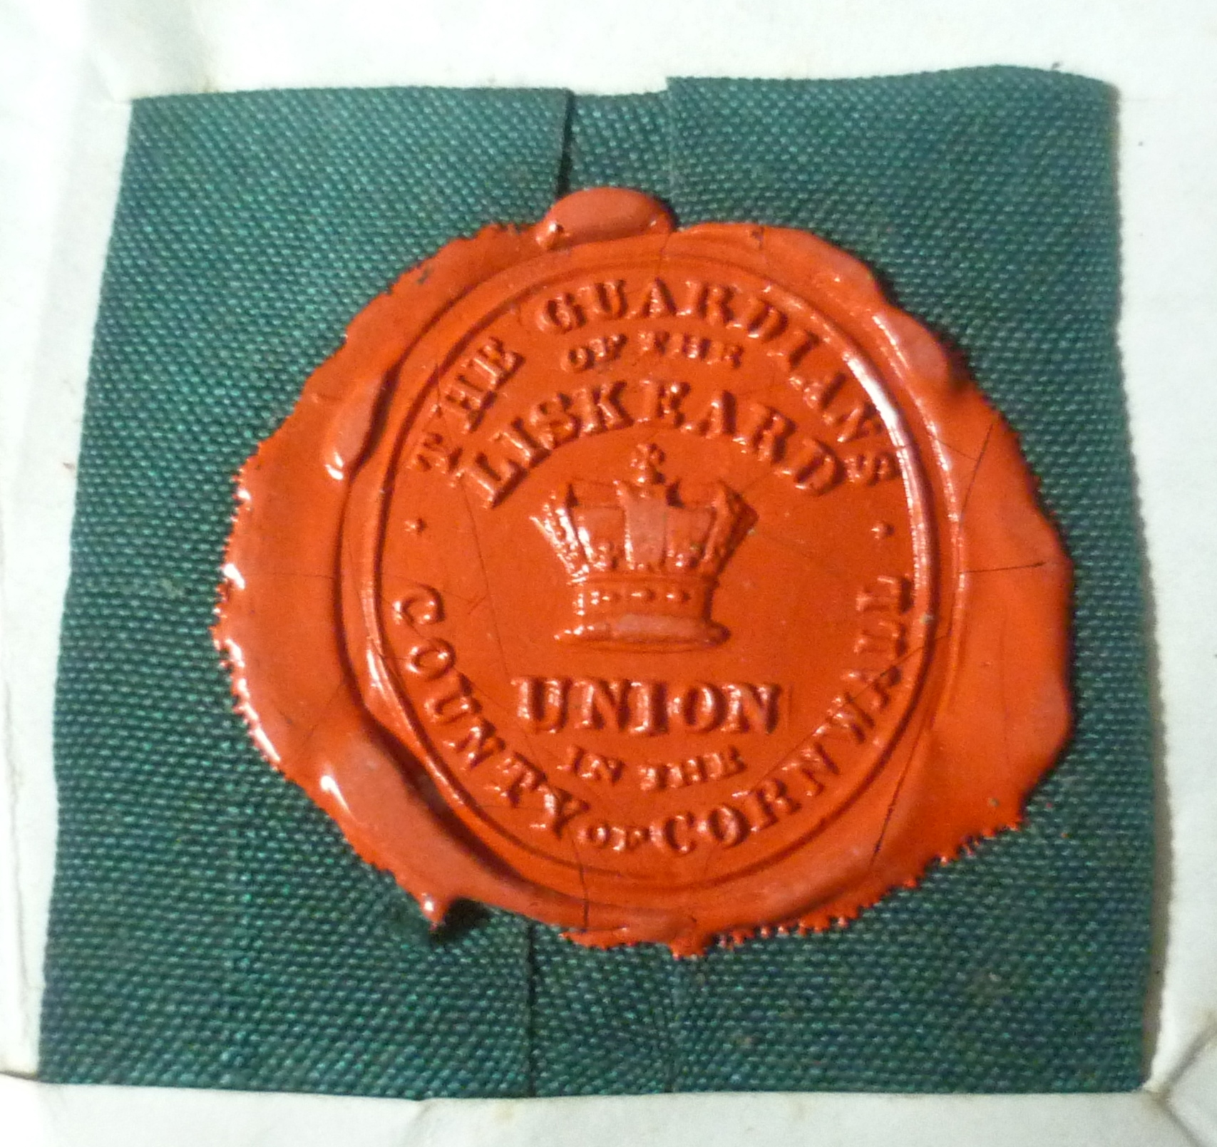
C.22.7. Conveyance, 27 November 1849 , Charles Atmore Ogilvie DD to the College, of the land in C.22.6, which abutted the eastern side of Duloe Churchyard between it and the village road, and had by then been planted with trees, the paupers house having been demolished.
C.22.8. Lease, 2 September 1562, Henry Parry (Parey), Clerk and Parson of the Rectory and Prebendal Church of Duloe, to Richard Caple, Gentleman of Duloe, of the Rectory lands etc, but reserving the Patronage of the Perpetual Vicarage to himself.
C.22.9a. Note, nd but ca. 1610, concerning presentations to Duloe (Dewloe). One paper leaf written both sides, worn and fragile. See also C.22.50 and 51.
C.22.9b. Lease, 25 August 1608, Michael Cosowarth, Clerk, Parson of Duloe, and Edward Cosowarth Gentleman of Cosowarth, to Thomas Arundel Esq. of Tremadart, of Duloe tithes etc. One large paper leaf worn and badly torn, and only just in one piece. Signed “By mee Michaell Cosowarth “; small seal applied to the paper lost. Endorsed as witnessed by George Pyper and John Hornaman.
C.22.9c. Note, nd but on internal evidence ca. 1585, concerning the Advowson. One paper leaf written both sides, worn.
C.22.9d . Presentation, 2 October 1647, by John St Aubyn (signing John Seyntaubyn) of James Forbes to the Church of Duloe following the death of Edward Cotton, previous incumbent. One paper sheet, stained but physically sound.
C.22.9e. Presentation, 2 October 1647, by Thomas Arundel. Paleographically challenging, a single paper leaf.
C.22.9f. Parliamentiary Order, 25 May 1648, for James Forbes to be inducted at Duloe. Signed Jo: Browne. John Brown was Clerk to Parliament. One folded foolscap sheet, worn but in fair condition.
C.22.9g. Commission, 5 May 1648, from Thomas Benet, for the induction of James Forbes at Duloe. With a large seal impressed on the paper much cracked and 25% lost. Contemporary annotation that James Forbes took posession of Duloe ( Deulo) Church on 6 June 1648 according to ancient custom, tolling the great bell three times, witnesses signing : George Phare Rector of St Keyne,Thomas Couch, John Flammock, John Kitt…. and William Stephens.
C.22.9h. Charge, 1652, that James Forbes Clerk late of Duloe did with force and arms break and enter the house of Arthur Bury Clerk.Three leaves secured together.
C.22.10-26. Papers concerning the affair in C.22.9h, 1653-1662. C.22.14a, C.22.18 and C.22.24 were noted as not found in 2003, but were found out of place in 2015; C.22.14b was not found in 2003 or 2015. Arthur Bury, a Royalist, was later controversial Rector of Exeter College Oxford.
C.22.27a-30. Papers concerning the vacancy at Duloe, 1682-1683.
C.22.31. Acknowledgment, 23 July 1701, by John Arundel Esq. (signing Jo:Arundell) of Tremidart that he had received from William Brydges Esq. of the Middle Temple on behalf of the College £175, part of his share of the consideration money mentioned in C.22.1. Witnesses signing J Fulham, John Anstis Junr ,Wm Brydges.
C.22.32 Bill of Costs, annotated “pd March 7. 1701/2”
C.22.33-46. Previously noted as void numbers, probably arising from 19th century confusions. For example. the document labelled C,22.32 and described under that code here also bears the code in pencil C.22.42.
C.22.47 & 48. Tightly rolled stiff parchment documents probably concerning the acquisition of the Advowson by the College ca. 1701, not fully examined.
C.22.49. MS Copy Act of Parliament, “Anno 10º Annae Regin. An Act for making a perpetual augmentation to the Vicaridge of Duloe in the county of Cornwal out of the Tythes and profitts of the Rectory of Duloe.” Made at the instance of the College as lay Rector, the Bishop of Exeter, and Jeremiah Milles the Vicar. Five membranes sewn together. Signed at the end of the fifth membrane ”Math ;Johnson Cler˜ parliamentor˜”. Not found in 2003 but found in 2015. A long document in a somewhat cumbersome roll, but in good order.
C.22.50 and 51. Notes, very similar in content and date to C.22.9a. Noted as not found in 2003, but found in 2015.
C.22.52. Agreement after Arbitration, made at Duloe 9 June 1636, between Thomas Arundel ( for himself and John St Aubyn Esq., written John Seyntaubyn) and William Bastard Esq., Joseph Bastard, Richard Bayley Gentleman, William Stephens Clerk and Oliver Jagoe Yeoman, concerning the Tithes and Vicarage of Duloe . There were three Arbitrators who all signed:
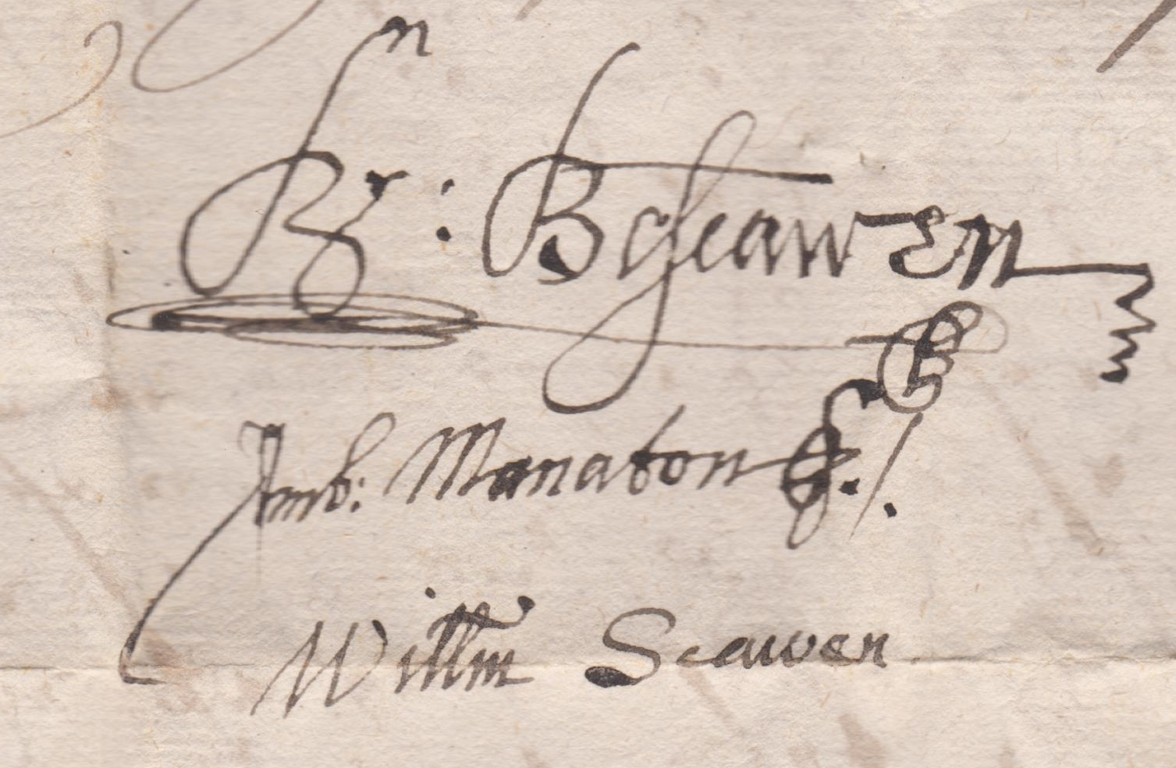
The second Arbitrator here was Ambrose Manaton , Recorder of Launceston.The parties all signed except Oliver Jagoe (William Stephens signing Wyllyam Stephens Vicar) and there were eight others in whose presence this took place, all signing their names .
C.22.53. Agreement, 20 April 1665, between John St Aubyn (Seyntaubyn) of Clowance and John Arundell Esq. of Tremidart (Tremydart), tenants in common of the Advowson of Duloe (current incumbent James Forbes Clerk ,presented by Thomas Arundell, deceased father of the said John Arundell), that John St Aubyn should have the next presentation and thereafter presentations should be by turn. Original, parchment, soiled but legible. Signed and sealed by John Arundell only; endorsed with the witness signatures of William Lamp….. and John Searle ; Cornelius Cary made his mark CO.
C.22.54. Contemporary certified copy of C.22.53 on paper. Worn.
C.22.55. Grant, 13 February 1684/5, John Arundell to Theophilus Oglethorpe Esq. of St Martin in the Fields Middlesex ,of the presentation to Duloe following the death deprivation or resignation of James Fincher Clerk then incumbent. Endorsed on 1 August 1698 by Theophilus Oglethorpe, assigning his title to Mr Mills. Very soiled; seal missing. Deliberately defaced with two large crosses cut with a sharp knife.
C.22.56. ALS,from Bath Wednesday Morning otherwise nd., George Trym addressed to Thomas Knight Esq. “att his house in Corne Street Bristol” enclosing a draft concerning the Advowson . And on the same leaf ALS 8 February 1698/9 Thomas Knight’s reply returning the draft and commenting on a legal technicality.
C.22.57. Agreement, 12 October 1700, between Theophilius Oglethorpe and John Arundell that the former gives up his right to the next presentation for £50 of which five guineas had been paid, the balance to be paid “att his dwelling house in Godallming in Surry”, noting that the present incumbent Mr Fyncher “is in his usual health “ and subject to his survival for at least one month. Signed and sealed by both parties, witnesses including “J^{n} Combs Coffee Man”. This is a formal Deed in the sense of being executed and stamped but is not in a legal clerk’s hand( it is probablyu all in that of Theophilus Oglethorpe) with some interlining .
C.22.58. ALS, 26 April 1701, Theophilus Oglethorpe to Mr John Anstis “at ye Upholsterers in Arrundall Streete “, asking him to pay the money due from Mr Arundell to his son, annotated with a receipt for £44.12.6 signed by L Oglethorpe on 28 April 1701, witnessed by John Anstsis.
C.22.59. ALS, 24 July 1701, John Powell, addressed “For the Reverend D^{r} Maunder Vicechancellor of the University of Oxford at Baliol Colledge “, concerning the Advowson, commenting that “ M^{r} Briges hath been very carefull about your purchase” and sending greeting to the Fellows of his acquaintance.
C.22.60. Bond, 3 Jul 1701, John St Aubyn (who signed thus) Bt of Clowance & John Arundell ( who signed Jo. Arundell) of Tremidart to the College concerning the transfer of the Advowson. Witnesses signed: J Fulham, John Anstis Jun^{r}., & W^{m} Brydges.
C.22.61. Receipt, 23 July 1701, from “Sir John Saint Aubyn of Clowance in the County of Cornwall Baronet” that he has received £325 from William Brydges of the Middle Temple acting on behalf of the College. Witnesses as C.22.60.
C.22.62. Final Concord, 8 March year unclear, at Oxford before Orlando Bridgeman and others, concerning Duloe. Latin and paleographically challenging.A true copy of the original certified by Nicholas Moone or Moons and another on 19 August 1682.
C.22.62*. Power of Attorney, 1 April 1779, by which John Cooke MA Rector of Duloe appointed Richard Heighway Fellow of Balliol his attorney concerning Duloe, mentioning that John Coles was then Vicar of Duloe .Signed and sealed by John Cooke, witnesses signing Jnº Davey and R. Prosser. Annotated with an authority to M^{r} James Morrell to receive moneys due from the Vicar of Duloe to the Rector of Duloe, signed Rich^{d} Heighway, 6 January 1781. Endorsed with commentary in the hand of Richard Jenkyns, nd. Arthur Owen inserted this document under code C.22.62 in error, the number having already been used. It remains, now under code C.22.62*, in the envelope provided by Arthur Owen, annotated in his hand.
C.22.63. Three contemporarily attached small parchment pieces concerning the case between James Forbes and Arthur Bury, including one piece giving the names of the Jurors. Much detail survives in these but all are major paleographic challenges.
C.22.64. ALS , from Stonehouse 30 May 1872, signature probably Charles TV Lewis, to the Revd Paul Bush at Duloe Rectory concerning the fencing off of some waste land at Duloe (part of the Glebe) north of the road from Duloe towards Sandplace and south of land belonging to the Revd Thomas Arthur Bewes , in the latter’s favour,
C.22.65-66. Previously listed as Schedules of Deeds .Not found 1990 or since.
C.22.67. Letters (10, all ALS, 1858-1860), Revd Paul Bush, mostly from Duloe Rectory to Robert Scott Master of Balliol, concerning Rectory business, especially Land Tax. In an envelope annotated in the hand of EV Quinn.

JH Jones, 26 May 2015.

